Application of the Grid􏰀haracteristic Method on Unstructured
Tetrahedral Meshes to the Solution of Direct Problems
in Seismic Exploration of Fractured Layers
V. A. Biryukov, M. V. Muratov, I. B. Petrov, A. V. Sannikov, and A. V. Favorskaya
Moscow Institute of Physics and Technology (State University), Institutskii per. 9, Dolgoprudnyi, Moscow oblast, 141700 Russia e􏰀mail: biryukov.vova@gmail.com, max.muratov@gmail.com, petrov@mipt.ru, donxenapo@gmail.com, aleanera@yandex.ru Received October 22, 2014; in final form, April 28, 2015
Abstract—Seismic responses from fractured geological layers are mathematically simulated by apply􏰀 ing the grid􏰀characteristic method on unstructured tetrahedral meshes with the use of high􏰀perfor􏰀 mance computer systems. The method is intended for computing complicated spatial dynamical pro􏰀 cesses in complex heterogeneous media and is characterized by exact formulation of contact condi􏰀 tions. As a result, it can be applied to the simulation of seismic exploration problems, including in regions with a large number of inhomogeneities, examples of which are fractured structures. The use of unstructured tetrahedral meshes makes it possible to specify geological cracks of various shapes and spa􏰀 tial orientations. As a result, problems are solved in a formulation maximally close to an actual situation. A cluster of computers is used to improve the accuracy of the computation by optimizing its duration.
DOI: 10.1134/S0965542515100073
Keywords: grid􏰀characteristic method, unstructured tetrahedral meshes, seismic exploration, frac􏰀 tured media, seismic waves, numerical simulation, high􏰀performance computer systems, parallel algorithms.
INTRODUCTION
At present, seismic exploration is a major research method applied before direct drilling [1]. Seismic exploration research is used to determine the structure of rock layers and to identify possible fossil fuel deposits. Numerical experiments make it possible to optimize the interpretation of seismic exploration data, which reduces the costs of oil extraction. In the numerical simulation of such problems, we need to compute seismic wave propagation in rocks with a large number of arbitrarily located inhomogeneities that vary in shape, size, orientation, and physical properties.
To describe such a complex heterogeneous medium most precisely, an optimal approach is to use unstructured tetrahedral meshes, which make it possible to specify inhomogeneities (cracks) of any shape and spatial orientation.
Since the state of a linear elastic solid medium is mathematically simulated using a hyperbolic system of equations [2, 3], an optimal approach is to apply the grid􏰀characteristic method [4–11] with high􏰀order interpolation [12], which allows one to achieve the highest accuracy in the computation of wave propaga􏰀 tion.
Examples of using the grid􏰀characteristic method with high􏰀order interpolation on tetrahedral meshes can be found in [11].
The computation of three􏰀dimensional seismic exploration problems requires processing a large amount of data, so high􏰀performance computer systems have to be applied. In this work, we used a cluster of distributed memory computers, on which the developed algorithms were parallelized for optimal use of the resources.
A favorable difference of the approach used in this work from widespread models of effective media [13–16] is that inhomogeneities are directly specified in the integration domain. This approach provides more detailed wave response patterns and allows us to observe qualitatively new effects. Cracks are speci􏰀 fied in the form of contact or boundary conditions with the physical properties of the crack􏰀saturating fluid indicated to obtain the most accurate approximation to the model.
1733
1734 BIRYUKOV et al.
Below, we simulate the responses of systems of unidirectional cracks with heights comparable to the length of the incident wavefront. A detailed study of such geological structures is a major problem in mod􏰀 ern seismic exploration.
1. MATHEMATICAL MODEL According to [2], the state of a linear elastic medium is described by the system of equations
ρ∂tv = (∇⋅σ)т , (1) ∂σ=λ(∇⋅v)I+μ∇⊗v+(∇⊗v) . (2)
tensor:
For each of the three systems of the form
we have the exact expression
∂tq + A1∂ξ1q = 0 (4)
I q(ξ1,ξ2,ξ3,t + τ) = ∑Xiq(ξ1 − ciτ,ξ2,ξ3,t), (5)
i=1
t(т)
Equation (1) is a local equation of motion, in which ρ is the material density; v is the velocity of motion; and σ is the Cauchy stress tensor, which is symmetric due to the pair law of shear stresses. Equa􏰀 tion (2) is derived by differentiating Hooke’s law with respect to time. In (2) λ and μ are the Lamé con􏰀 stants, which determine the properties of the material.
The following notation is used below: ∂ta ≡ ∂a/∂t is the partial derivative of a field a with respect to t; a ⊗ b is the tensor product of vectors a and b , (a ⊗b)ij = aibj; and I is the unit tensor of the second rank.
2. NUMERICAL METHOD
System (1), (2) is solved numerically using the grid􏰀characteristic method on tetrahedral meshes [11]. As a result, correct numerical algorithms can be constructed for computing boundary points and points lying on interfaces between two media with different Lamé constants and (or) different densities.
At every integration time step, we choose three arbitrary directions forming a basis (which ensures the isotropy of the method) and introduce a new coordinate system (ξ1,ξ2,ξ3), in which system (1), (2) can be represented as
∂tq + A1∂ξ1q + A2∂ξ2q + A3∂ξ3q = 0, (3) where q is a vector composed of three velocity components and six components of the symmetric stress
q=⎡v⎤={v,v,v,σ ,σ ,σ ,σ ,σ ,σ }т. ⎢σ⎥ 1 2 3 11 22 33 23 13 12
⎣⎦
whereXi arematricesexpressedintermsoftheelementsofthematrixA1,ci aretheeigenvaluesofA1,and τ is the time integration step.
The eigenvalues of all three matrices are expressed in terms of the density and the Lamé constants as follows:
(6)
(7)
⎧12 1212121212⎫
c ∈ ⎪⎛λ + 2μ⎞ ,−⎛λ + 2μ⎞ ,⎛μ⎞ ,−⎛μ⎞ i⎨⎜ρ⎟⎜ρ⎟⎜ρ⎟⎜ρ⎟⎜ρ⎟⎜ρ⎟ ⎬
,⎛μ⎞ ,−⎛μ⎞ ,0,0,0⎪. ⎪⎝ ⎠ ⎝ ⎠ ⎝ ⎠ ⎝ ⎠ ⎝ ⎠ ⎝ ⎠ ⎪
⎩⎭
In (5) the action of the matrices X i on the unknown vector q can be written as
⎡(n⋅v)n∓ 1 (N00 ÷σ|)n X ⎡v⎤=1⎢ c1ρ
⎤
⎥, ⎥
1,2⎢σ⎥ 2⎢ ⎣ ⎦ ⎢∓ρ(n⋅v)((c1 −c3)N00 +c3I)+
1 ⎢ λ+2μ ⎥
(N00 ÷σ)(2μN00 +λI)⎥ ⎣⎦
COMPUTATIONAL MATHEMATICS AND MATHEMATICAL PHYSICS Vol. 55
No. 10
2015
APPLICATION OF THE GRID􏰀CHARACTERISTIC METHOD
1735
⎡v⎤ ⎡v⎤ 1⎡v−(n⋅v)n∓ 1 (σ⋅n−(N00 ÷σ)n) X3,4⎢⎥=X5,6⎢⎥= ⎢ c2ρ
⎤
⎥.(8) ⎣σ⎦ ⎣σ⎦ 2⎢∓с ρ(n⊗v+v⊗n−2(n⋅v)N )+n⊗(σ⋅n)+(σ⋅n)⊗n−2(σ÷N )N ⎥
⎣2 00 00 00⎦ The matrices X i has the property
∑Xi =I−∑Xi. ci =0 ci ≠0
In (6)–(8) n denotes the unit vector in the direction ξ1 for the matrix A1, N00 is the tensor N00 =n⊗n,
and A ÷B isascalar:
33
A ÷ B = ∑∑AijBij . i=1 j=1
Using high􏰀order interpolation in (5) and, in each of the directions ξ1, ξ2, and ξ3, sequentially applying formulas that are similar to (5) and correspond to a system of form (4), we obtain a method for finding the solution at the next time level. The software package applied involves interpolation of the first to fifth orders [12], thereby producing a numerical solution of high accuracy in space. Additionally, the applica􏰀 tion of the matrices X i is implemented with the help of two operators. As a result, the number of interpo􏰀 lations for each point and each direction is reduced from nine to six.
3. BOUNDARY AND CONTACT CORRECTORS
Based on the method applied, the most correct numerical algorithms can be used on the boundaries and interfaces of the integration domain.
Suppose that the boundary condition is written in matrix form as
Dq(ξ1,ξ2,ξ3,t + τ) = d, (7) where q(ξ1,ξ2,ξ3,t + τ) are the components of the velocity and the stress tensor at the next integration step
at a boundary point. Accordingto(6),eachmatrixAj hasthreezeroeigenvalues,threepositive,andthreenegativeones.
To be definite, assume that the characteristics corresponding to the negative eigenvalues of A1 go beyond the integration domain in the ξ1 direction.
Then, according to (5), the following sum is calculated at the stage of computing interior points:
qin (ξ1,ξ2,ξ3,t + τ) = ∑Xiq(ξ1 − ciτ,ξ2,ξ3,t). ci≥0
The matrix Ω*, out consists of the eigenvectors corresponding to the negative eigenvalues. The corrector at a boundary point is given by the formula
q(ξ1,ξ2,ξ3,t + τ) = Fqin (ξ1,ξ2,ξ3,t + τ) + Φd, and condition (7) is satisfied to the same order as that of the interpolation.
(8)
The matrix (DΩ*, out)−1 in formula (8) is found so as to satisfy (DΩ*, out)−1DΩ*, out = I,
while the matrices Φ and F are given by the formulas Φ = Ω*, out(DΩ*, out)−1,
F = I − ΦD. COMPUTATIONAL MATHEMATICS AND MATHEMATICAL PHYSICS
Vol. 55
No. 10
2015
1736 BIRYUKOV et al.
In various problems, the boundary conditions are specified as a given external force, a given boundary velocity, mixed boundary conditions, and nonreflecting boundary conditions with outgoing characteris􏰀 tics set to zero. In the case of nonreflecting boundary conditions, relation (7) becomes
Ωout,l/rq(t+τ,r )=0 k гр
4. CONDITIONS ON A CRACK
It was found that the most optimal approach in terms of the efficiency of computing actual inhomoge􏰀 neities [16] is to specify cracks in the form of contact or boundary conditions. Several crack models spec􏰀 ified by various conditions were developed. A crack was assumed to be infinitely thin and filled with a fluid (oil, liquefied gas, or water).
First, we consider two limiting cases of a crack: (i) an open crack filled with a fluid; and (ii) a closed crack, i.e., a crack with edges completely joined together with no fluid in between.
The contact glide condition was used in case (i). This is the mixed contact condition
where V p and fτ = 0 are substituted into the contact conditions for one crack edge with outward normal p, and −Vp and fτ = 0, for the other.
In case (ii), we applied the no􏰀glide condition
in in in in
Vp =(ρaca1va +ρbcb1vb −(σa −σb )⋅p)⋅p, ρaca1 + ρbcb1
1 a,in a,in V=ρc +ρc (ρa((p⋅v )(c1a −c2a)p+c2av )+
−
(p⋅((ρac1av
b,in
)−(σ
a,in
b,in ⎞ )⋅p))p⎟.
+ρb((p⋅v ρa (c1a −c2a)+ρb (c1b −c2b)
)⋅p−
a 2a
b,in
b 2b )(c1b −c2b)p+c2bv
a,in
b,in a,in b,in )−(σ −σ
−σ Next, a boundary condition with a given velocity was used for each of the crack edges.
ρ c +ρ c a 1a b 1b
+ρbc1bv
⎠
Actual cracks are combinations of these two model cracks. A crack is closed at some points, while open and filled with a fluid at other points. To simulate such a situation, we developed a crack model with dynamical friction. The computations were performed according to the following algorithm.
Step 1. Compute the case of a completely closed crack to determine the force f* at the crack edges. Step 2. If f* > k f * , then compute the friction
τp
fp=
B,in A,in B,in A,in ρAcA,1ρBcB,1((v ⋅p)−(v ⋅p))+ρAcA,1(σ ÷N00)+ρBcB,1(σ ÷N00)
1 B,in B,in +ρ c ((σ ⋅p)−(σ
B B,2
1 A,in ÷N00)p)+ρ c ((σ ⋅p)−(σ
A,in
÷N00)p),
ρc +ρc A A,1 B B,1
R=vB,in −(vB,in ⋅p)p−vA,in +(vA,in ⋅p)p+
,
A A,2 f =kf R,
τpR f = fpp+fτ.
Next, the given external force f is used as a boundary condition on one edge of the crack and −f is used on the other.
Similar computations were performed in the case of a free boundary condition specified on the crack, which approximates an empty (gas􏰀saturated) crack. In this case, the response is the strongest and its structure can be considered in detail.
COMPUTATIONAL MATHEMATICS AND MATHEMATICAL PHYSICS Vol. 55 No. 10 2015
APPLICATION OF THE GRID􏰀CHARACTERISTIC METHOD 1737
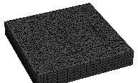
Fig. 1. Example of a tetrahedral unstructured mesh with cracks.
5. UNSTRUCTURED TETRAHEDRAL MESHES
To specify cracks of complex geometry in geo􏰀 logical layers, we applied unstructured tetrahedral meshes. They were constructed using a modified version of the open library tetgen. An integration domain with inclusions (cracks) was set first. Then the domain was uniformly filled with tetra􏰀 hedra of prescribed minimum volume so that the Delaunay criterion was satisfied. Next, the points on the boundaries of the domain and the cracks were optimized for the subsequent computations. The mesh was divided into portions to be used on distribute􏰀memory computer systems. Each mesh block consisting of the coordinates of nodes, tet􏰀 rahedra, triangles, and contact pairs of triangles on opposite sides of the cracks was stored in a binary file and was used by a separate computa􏰀 tional node in running the numerical module. Due to the separation of the computational domain between the nodes of the computer sys􏰀 tem at the initial stage, the amount of data sent out in the course of the computation was mini􏰀 mized, which ensured high efficiency and good scalability of the code. Figure 1 gives an example of a tetrahedral mesh.
6. FEATURES OF THE ROCK MODELS
In the computations, we used rock models based on geometric and physical characteristics maximally similar to actual media.
The integration domain was a box of size 10 × 10 × 3 km. Inhomogeneities (cracks) were placed at a depth of 2 km. The medium parameters were specified as similar to carbonates: the velocities of longitudinal and transverse waves were Vp = 4500 m/s and Vs = 2250 m/s, respectively, and the density was p = 2500 kg/m.
We studied the responses from subvertical cracks of height of about 100 m. The following three models were considered: (1) a single crack, (2) a set (cluster) of unidirectional cracks (Fig. 2), and (3) a set of intersecting cracks (Fig. 3).
The initial perturbation was represented by a plane wave pulse (step) with a wavelength of 150 m.
The results were written in the form of wave patterns of velocity fields in the entire integration domain and in the form of synthetic seismograms from receivers located on the ground surface (day􏰀 time surface).
7. RESULTS
Response of a single crack. The 3D simulation of wave propagation in a medium with a single crack was performed. A plane wavefront propa􏰀
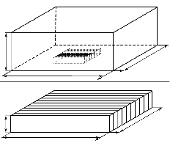
10 km
Y
X
Y 3 km X
Fig. 2. Schematic diagram of the system of cracks in the considered problem with geometric sizes indicated.
Fig. 3. Schematic diagram of crack location in a system of intersecting cracks.
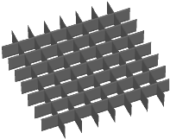
COMPUTATIONAL MATHEMATICS AND MATHEMATICAL PHYSICS Vol. 55 No. 10 2015
100 m 3 km
10 km
3 km
1738
BIRYUKOV et al.
0.5 0.6 0.7 0.8 0.9 1.0 1.1 1.2 1.3 1.4 1.5 1.6 1.7 1.8
0.5 0.6 0.7 0.8 0.9 1.0 1.1 1.2 1.3 1.4 1.5 1.6 1.7 1.8
(a)
(a)
(b) (c)
Fig. 4. Seismograms of the response of a single liquid􏰀saturated crack.
(b) (c)
Fig. 5. Seismograms of the response of a single empty crack.
- 0.5 0.5
- 0.6 0.6
- 0.7 0.7
- 0.8 0.8
- 0.9 0.9
- 1.0 1.0
- 1.1 1.1
- 1.2 1.2
- 1.3 1.3
- 1.4 1.4
- 1.5 1.5
- 1.6 1.6
- 1.7 1.7
- 1.8 1.8
- 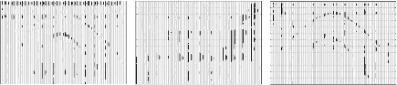
- 0.5 0.5
- 0.6 0.6
- 0.7 0.7
- 0.8 0.8
- 0.9 0.9
- 1.0 1.0
- 1.1 1.1
- 1.2 1.2
- 1.3 1.3
- 1.4 1.4
- 1.5 1.5
- 1.6 1.6
- 1.7 1.7
- 1.8 1.8
(a)
(b)
(c)
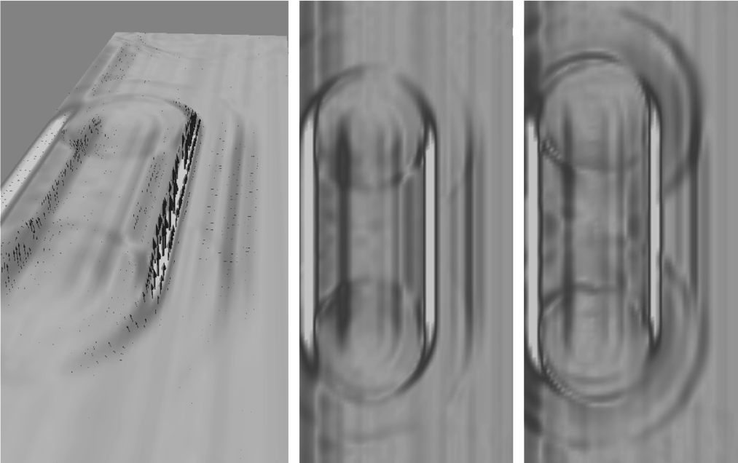
Fig. 6. Two􏰀dimensional wave patterns of the response of a system of unidirectional liquid􏰀saturated cracks (a), (b) in a plane along the crack direction and (c) in a plane across the crack direction.
gated along a crack inclined at a small angle (of about 5°), forming a scattered wave response propagating toward the surface, where it was recorded by seismometers. Seismograms are displayed in Fig. 4. Each ver􏰀 tical line in a seismogram represents a one􏰀dimensional plot of the velocity component obtained at the corresponding seismometer. The figure shows seismograms for three spatial velocity components (a) X, (b) Y, and (c) Z in the case of receivers placed across the plane of the cracks. The response consists of the more intense transverse and less pronounced longitudinal components of the wave scattered by the crack.
A more intense response was obtained in the case of an empty crack (see Fig. 5). Here, the energy of the longitudinal wave prevails in the response.
COMPUTATIONAL MATHEMATICS AND MATHEMATICAL PHYSICS Vol. 55 No. 10 2015
APPLICATION OF THE GRID􏰀CHARACTERISTIC METHOD 1739
Vx
Vy
Vz
Fig. 7. Seismograms of the wave response of a system of unidirectional liquid􏰀saturated cracks.
It should be noted that the numerical results are similar to those obtained in 2D simulations (see [17– 19]). An issue of special interest is the results obtained from the sensors located along the crack plane, since they cannot be obtained in two􏰀dimensional simulation.
Response of a set of cracks. We investigated the response of a set (cluster) of unidirectional cracks shown schematically in Fig. 2. The cracks were spaced 100 m apart, which was equal to their height. The horizontal sizes of the cluster were 3 × 3 km.
Figure 6 shows the wave patterns of the response in planes parallel and perpendicular to the cracks. The corresponding seismograms of the response are presented in Fig. 7. Figure 8 depicts the two􏰀dimensional area pattern of the response (two􏰀dimensional wave pattern in the plane of the medium surface where the receivers are located) obtained from all sensors on the surface at three different times in the course of arriv􏰀 ing the basic energy of the response.
The major portion of the response is represented by a plane wave of multiphase structure propagating upward from the crack cluster. Such a structure is most pronounced in the case of empty cracks (Fig. 9), since the response is stronger.
COMPUTATIONAL MATHEMATICS AND MATHEMATICAL PHYSICS Vol. 55 No. 10 2015
1740 BIRYUKOV et al.
0.5 0.6 0.7 0.8
- Vx 0.9 1.0 1.1 1.2 1.3 1.4 1.5 1.6 1.7 1.8 0.5 0.6 0.7 0.8 0.9 1.0
- Vy 1.1 1.2 1.3 1.4 1.5 1.6 1.7 1.8 0.5 0.6 0.7 0.8 0.9 1.0
- Vz 1.1 1.2 1.3 1.4 1.5 1.6 1.7 1.8
t = 1.18 s t = 1.23 s t = 1.28 s Fig. 8. Two􏰀dimensional patterns of the response of liquid􏰀saturated surface cracks (area patterns).
0.5
0.6
0.7
0.8
0.9
1.0
1.1
1.2
1.3
1.4
1.5
1.6
1.7
1.8 0.5
0.6
0.7
0.8
0.9
1.0
1.1
1.2
1.3
1.4
1.5
1.6
1.7
1.8 0.5
0.6 0.7 0.8 0.9 1.0 1.1 1.2 1.3 1.4 1.5 1.6 1.7 1.8
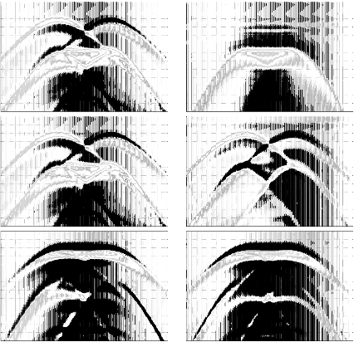
Fig. 9. Seismograms of the wave response of a system of unidirectional empty cracks. COMPUTATIONAL MATHEMATICS AND MATHEMATICAL PHYSICS Vol. 55 No. 10 2015
APPLICATION OF THE GRID􏰀CHARACTERISTIC METHOD 1741
(a) (b)
Fig. 10. Two􏰀dimensional wave patterns of the response of a system of cross cracks in (a) vertical plane and (b) horizontal plane.
Response of a system of cross cracks. We studied the response of a system of cross cracks (see Fig. 3). Figure 10 presents the wave patterns of the response after the flat wavefront passed through the system. Specifically, one of the vertical planes in which the wavefront propagates is shown in Fig. 10a, while the pattern in a horizontal plane intersecting the crack is displayed in Fig. 10b.
The results of this work were obtained using the computational resources of the Multifunctional Com􏰀 puting Center of the National Research Center “Kurchatov Institute” (http://computing.kiae.ru/).
ACKNOWLEDGMENTS This work was supported by the Russian Science Foundation, grant no. 14􏰀11􏰀00263.
REFERENCES
- R.E.SheriffandL.P.Geldart,ExplorationSeismology(CambridgeUniv.Press,Cambridge,1982;Mir,Moscow, 1987).
- W. Nowacki, Thermoelasticity (Pergamon, Oxford, 1962; Mir, Moscow, 1975).
- V. I. Kondaurov and V. E. Fortov, Fundamentals of Thermal Mechanics of Condensed Media (Mosk. Fiz.􏰀Tekh. Inst., Moscow, 2002) [in Russian].
- K. M. Magomedov and A. S. Kholodov, Grid􏰀Characteristic Numerical Methods (Nauka, Moscow, 1988) [in Russian].
- A. G. Kulikovskii, N. V. Pogorelov, and A. Yu. Semenov, Mathematical Aspects of Numerical Solution of Hyper􏰀 bolic Systems (Fizmatlit, Moscow, 2001; Chapman and Hall/CRC, London, 2001).
- I.B.PetrovandA.S.Kholodov,“Numericalstudyofsomedynamicproblemsofthemechanicsofadeformable rigid body by the mesh􏰀characteristic method,” USSR Comput. Math. Math. Phys. 24 (3), 61–73 (1984).
- A. S. Kholodov, “Numerical methods for solving hyperbolic equations and systems,” in Encyclopedia of Low􏰀 Temperature Plasmas (Yanus􏰀K, Moscow, 2008), Vol. VII􏰀1, Part 2, pp. 141–174 [in Russian].
- V.D.Ivanov,V.I.Kondaurov,I.B.Petrov,andA.S.Kholodov,“Computationofdynamicdeformationandfrac􏰀 ture of elastoplastic bodies by grid􏰀characteristic methods,” Mat. Model. 2 (1), 11–29 (1990).
- I. B. Petrov and A. S. Kholodov, “Regularization of discontinuous numerical solutions of equations of hyper􏰀 bolic type,” USSR Comput. Math. Math. Phys. 24 (4), 128–138 (1984).
- I. B. Petrov, A. G. Tormasov, and A. S. Kholodov, “On the use of hybrid grid􏰀characteristic schemes for the numerical solution of three􏰀dimensional problems in the dynamics of a deformable solid,” USSR Comput. Math. Math. Phys. 30 (4), 191–196 (1990).
- A. V. Favorskaya, I. B. Petrov, I. E. Kvasov, and A. V. Sannikov, “Grid􏰀characteristic method using high􏰀order interpolation on tetrahedral hierarchical meshes with a multiple time step,” Math. Model. Comput. Simul. 5 (5), 409–415 (2013).
ZY X Y Z X
COMPUTATIONAL MATHEMATICS AND MATHEMATICAL PHYSICS Vol. 55 No. 10 2015
1742 BIRYUKOV et al.
- I. B. Petrov and A. V. Favorskaya, “Library of high􏰀order interpolation methods on unstructured triangular and tetrahedral meshes,” Zh. Inf. Tekhnol., No. 9, 30–32 (2011).
- C.J.HsuandM.Schoenberg,“Elasticwavesthroughasimulatedfracturedmedium,”Geophysics58(7),964– 977 (1993).
- M. E. Willis, at al., “Spatial orientation and distribution of reservoir fractures from scattered seismic energy,” Geophysics 71 (5), 43–51 (2006).
- L.A.MolotkovandA.V.Bakulin,“Effectivemodelofalayeredelasticporousmedium,”Dokl.Akad.Nauk372 (1), 108–112 (2000).
- E. A. Kozlov, Medium Models in Exploration Seismology (Gers, Tver, 2006) [in Russian].
- V. B. Levyant, I. B. Petrov, and I. E. Kvasov, “Numerical simulation of wave response of subvertical macrofrac􏰀 tures, possible fluid􏰀conducting channels,” Tekhnol. Seismorazvedki, No. 4, 4–29 (2011).
- V. B. Levyant, I. B. Petrov, and M. V. Muratov, “Numerical simulation of wave responses from subvertical mac􏰀 rofractures system,” Tekhnol. Seismorazvedki, No. 1, 5–21 (2012).
- V. B. Levyant, I. B. Petrov, M. V. Muratov, and S. A. Byko, “Stability analysis of the formation of a front of con􏰀 verted waves from a zone of macrofractures,” Tekhnol. Seismorazvedki, No. 1, 32–45 (2013). Translated by I. Ruzanova
COMPUTATIONAL MATHEMATICS AND MATHEMATICAL PHYSICS Vol. 55 No. 10 2015

